**BIGDATA 4th Experiment:**

**Priyanka Dattatreya Hegde**

**1NT20Is407**

**C3 batch**

**Code:**

**package suchithra162;**

**import java.io.IOException;**

**import java.util.*;**

**import org.apache.hadoop.fs.Path;**

**import org.apache.hadoop.io.*;**

**import org.apache.hadoop.mapred.*;**

**public class TransactionCount {**

**//MAPPER CODE**

**public static class Map extends MapReduceBase implements**

**Mapper<LongWritable, Text, Text, IntWritable> {**

**private final static IntWritable one = new IntWritable(1);**

**//private Text word = new Text();**

**public void map(LongWritable key, Text value, OutputCollector<Text,**

**IntWritable> output, Reporter reporter) throws IOException {**

**String myString = value.toString();**

**String[] userCount = myString.split(",");**

**output.collect(new Text(userCount[3]), one);**

**}**

**}**

**//REDUCER CODE**

**public static class Reduce extends MapReduceBase implements**

**Reducer<Text, IntWritable, Text, IntWritable> {**

**public void reduce(Text key, Iterator<IntWritable> values,**

**OutputCollector<Text, IntWritable> output, Reporter reporter) throws**

**IOException { //{little: {1,1}}**

**int finaluserCount = 0 ;**

**Text mykey = key ;**

**while(values.hasNext()) {**

**IntWritable value = values.next();**

**finaluserCount += value.get();**

**}**

**output.collect(mykey, new IntWritable(finaluserCount));**

**}**

**}**

**//DRIVER CODE**

**public static void main(String[] args) throws Exception {**

**JobConf conf = new JobConf(TransactionCount.class);**

**conf.setJobName("wordcount");**

**conf.setOutputKeyClass(Text.class);**

**conf.setOutputValueClass(IntWritable.class);**

**conf.setMapperClass(Map.class);**

**conf.setCombinerClass(Reduce.class);**

**conf.setReducerClass(Reduce.class);**

**conf.setInputFormat(TextInputFormat.class);**

**conf.setOutputFormat(TextOutputFormat.class);**

**FileInputFormat.setInputPaths(conf, new Path(args[0]));**

**FileOutputFormat.setOutputPath(conf, new Path(args[1]));**

**JobClient.runJob(conf);**

**}**

**}**

**Output:jps& starting the hadoop**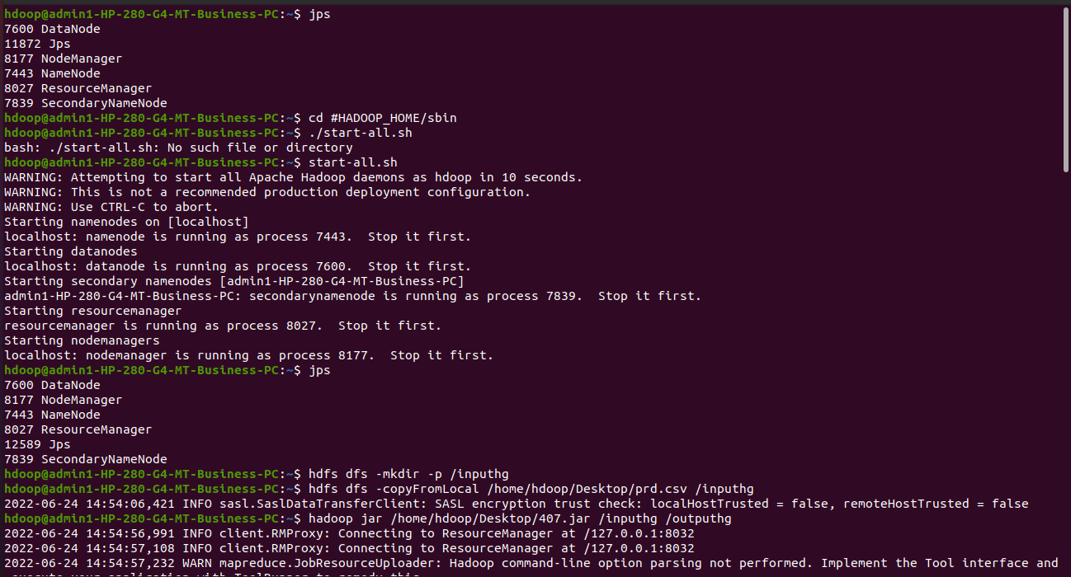

**Making input directory and input csv files:&jar file**

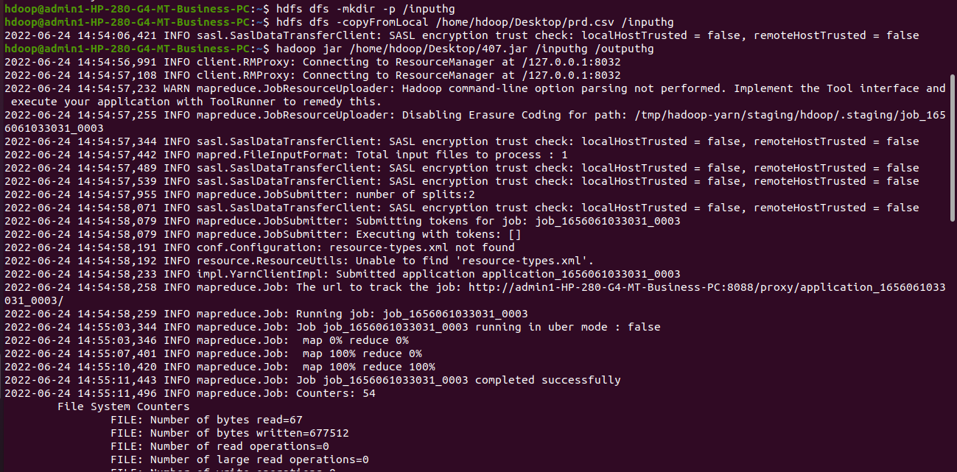

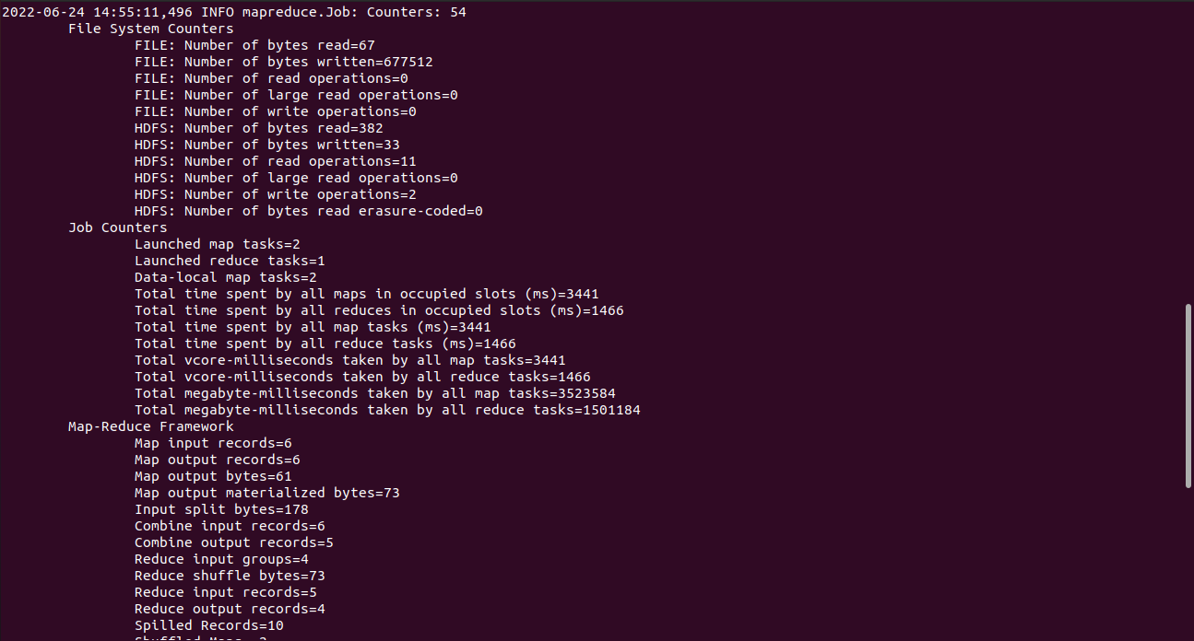

**Output:**

